
Building the Global Adaptation Index™
GaIn™
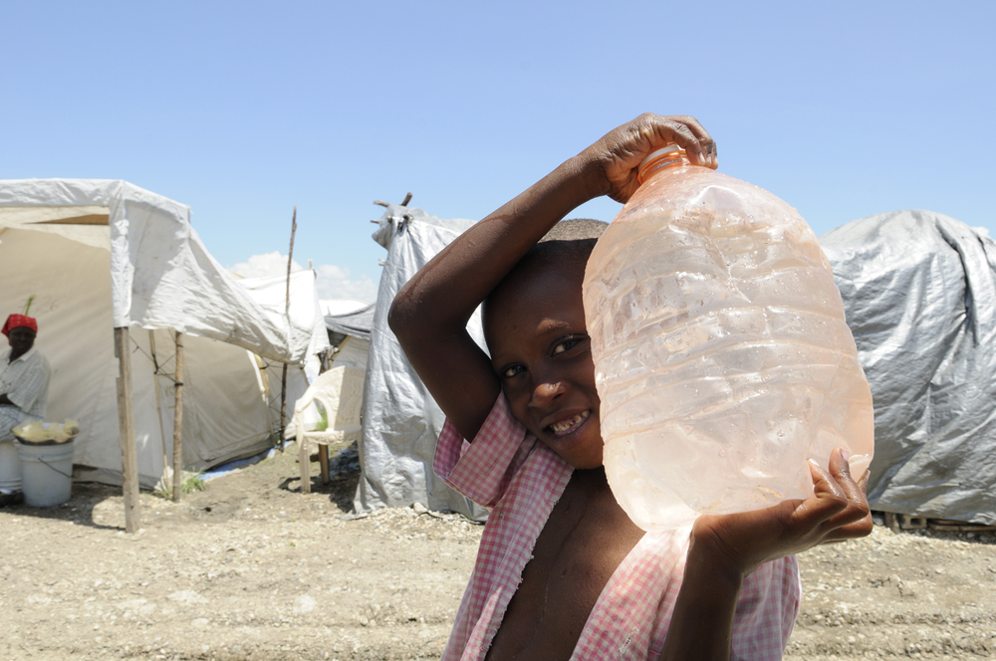

Produced by the Global Adaptation Institute, which retains all rights.
Not for quotation or circulation without the Institute’s written permission.

Washington, DC

Readiness Matrix: September, 2010
GaIn™ original version: February, 2011
GaIn™ last revision: April 21, 2011

1747 Pennsylvania Avenue, NW - Suite 1125 - Washington, DC 20006 . Tel (202) 559-4549 . Fax (202) 595-8963
http://www.globaladaptationinstitute.org/

Table of Contents
Table of Contents 2
Foreword 4
Our Vision 4
Our Mission 5
Measuring What Matters 5
Audience 5
Conclusion and Next Steps 5
Executive Summary 8
Introduction 10
The Model 11
Implementation 11
GaIn™ Structure 11
Weighting Criteria 14
Methodology 14
Other Notes regarding the methodology: 16
Vulnerability Categories and Indicators 17
Biophysical Exposure 18
Socioeconomic Sensitivity 20
Socioeconomic Adaptive Capacity 21
Energy/Other sectors 23
Readiness Categories and Indicators 24
Economic 24
Social 25
Governance 26
Adaptometer™ 28
Results 29
Ranking table 29
Readiness Bar plot 31
Vulnerability Bar Plot 31
Stacked bars 32
GaIn™ Map 33
Matrix 33
Change in readiness 35
GDP correlations 35
IEF vs. DBI indicators for Economic Readiness 38
References 39
Appendix 1: Glossary of Terms 43
Appendix 2: Scientists Meeting Attendees 45

Working Model for:
GaIn™ -- The Global Adaptation Index™

Foreword

Our Vision
The world is changing fast. Countries are being challenged to prepare for and, if possible, to minimize the effects of climate change within the context of other global trends such as population growth, urbanization, and economic growth. Resources have been committed from international institutions and more are being negotiated, but public funding alone is not the solution. The private sector will play a key role in the investments that are needed as well. With appropriate information all can contribute to increasing the resilience of local communities. The Global Adaptation Index™ (GaIn™) will become the navigation chart that will guide investments both private and public.

The Global Adaptation Institute www.globaladaptationinstitute.org, a non-profit environmental organization, is developing GaIn™ to compliment our future adaptation pilot projects and global outreach efforts. We are guided by a vision of building resilience against climate change and other global forces as a key component of sustainable development.

The Institute recognizes that mitigation continues to remain an essential global policy goal. As history has shown, increases in climate-related disasters and climate change will lead to increased risks and costs for businesses, complicate political decisions, and of most concern, threaten the quality of life for vulnerable populations around the world. However, the climate will continue changing to some degree throughout this century whether or not a binding international climate policy develops. Therefore, it is incumbent upon leaders in government, industry, and all forms of civil society to prepare for both anticipated and unforeseen risks to human life and livelihood.

In other words, we must adapt, and adapt in a way that is pragmatic, realistic and based on the principle that individuals should be able to take destiny into their own hands.

Our Mission
Our mission is to enhance the world's understanding of the urgency for adaptation to climate change and other global forces and for the support needed through private and public investments for developing countries. We will prioritize producing real results and real benefits as soon as possible.

We will raise awareness. We will help to mobilize the private sector. We will develop metrics, indicators, and other rigorous tools to encourage the greatest positive impact from resources used. We will directly fund pilot projects in adaptation and assist other private and public donors to do the same.

We will forge partnerships with other groups that share this positive vision. This vision has already enabled us to bring together 30 leaders from five continents to work on adaptation solutions and to gather 15 distinguished international experts and scientists for our first meetings on global adaptation metrics in September and October 2010.

Measuring What Matters
How can adaptation be made most effective? Where is the greatest need? Which countries and sectors are most resilient to climate challenges? Which adaptation investments will bring the greatest benefits for the largest number of people? What factors affect a country’s ability to implement the proposed changes? How are international priorities being set? Who is making the real choices?

This document describes our first attempt to address these pressing questions.

The Global Adaptation Index (GaIn™) measures two main concepts: First, the Vulnerability of a country to the effects of climate change and other global trends, and second, the Readiness of a country to successfully implement adaptation solutions. The Index currently consists of 18 indicators taken from a variety of data sources. There is not an established body of theory on how to derive indices such as these, but there is a wide constituency of experience and opinion that we have attempted to address. While we have included indicators from well-respected international institutions, scientific bodies, and think tanks, we remain open to alternate suggestions.

Audience
The GaIn™ model is intended to be a tool that decision makers in both the private and public sectors can use to save and improve the quality of lives. While there have been many tools that can assist policymakers, businesses, scientists, and other users in determining risks from climate change and other major trends, our goal is to create a facility that encourages users to move beyond descriptions and prediction to action. Our tool is intended to be pragmatic, actionable, and oriented toward delivering improvements in climate resilience through the enhancement of the governance and business environment in all countries.

This being said, we believe that government institutions, international non-profits, and major development funders are further along in developing metrics that represent their priorities for adaptation than is the private sector; guidance that will mobilize action from the private sector has been scarce. Thus, the indicators mentioned above and described in more detail throughout this document have been selected to help bring the private sector to the table.

Effective corporations and investors observe and respond to issues important to government and civil society. Effective governments and NGOs work with the private sector. Thus, our Index should be useful for all actors in gauging where private capital can “move the needle” on adaptation in a positive direction and where NGOs, development institutions and governments need to step in.

The results from our Index will not have the same meaning to everyone. A country may appear inhospitable for business investment due to a low degree of Readiness or high degree of Vulnerability. However, that same country may be an appropriate target for development support from government and international institutions. Within the private sector, there will likely be different interpretations of results from the Index as well. For many in the private sector this is the tool that will help in deciding where to invest in order to obtain an attractive rate of return and to help people in need.

Conclusion and Next Steps
There is not yet agreement on metrics for adaptation to climate change and other global trends. Agreement requires convergence from development, climate, ecosystems, entrepreneurship, public policy, and governance experts. However, we believe that the world should not wait for a global agreement before action is taken. We believe the global community should act quickly in those sectors we know are most vulnerable to climate change and to other global trends, and crucial to human well being.

This document presents the first working model of the Global Adaptation Index™ and preliminary results. We encourage reviewers to provide feedback, comments and criticism. An earlier version of this document has been circulated among a limited set of experts, and includes modifications and clarifications they proposed. Upon completion of this second restricted phase, we will enter an open round where anyone will have access to the model, the documentation, and the results.

We look forward to hearing your comments and criticisms during the upcoming May 3 meeting and/or through separate emails. Also, please contact us for further clarifications on any point.

After this second consultation step, the GaIn™ development process will:

- Begin an open consultation that will include scientists, economists, representatives from the private sector, policymakers, and representatives of NGOs and think tanks. Please share names of people and organizations to whom we should reach out.
- Release a Version 1.0 in late summer/early fall providing guidance for policymakers to begin implementing Adaptation efforts.
- Develop a permanent communications and outreach strategy with the private sector, NGOs, and government institutions. The hope is that these communications will provide feedback to ensure that our model is pragmatic and effective.
- Partner with other adaptation agents in promoting projects most likely to improve resilience in sectors most important to human prosperity, stability and health.
- Design and implement an “Adaptometer™” plan to capture “awareness”(described in the GaIn™ Structure section) by reaching out to local institutions and communities.

Keep in mind that this is a work in progress, and our current goal is to lay out our broad approach in developing the Index. With your and other reviewers’ engagement in this consultation process we can move forward towards a vision of a better future for all humanity.

Executive Summary

This document describes the first working model for GaIn™. It explains how and why indicators were chosen to measure both a country’s Vulnerability to the impacts of climate change and other global trends and its Readiness to implement adaptation solutions. It also shows how the indicators are combined to produce the overall score and the individual measures of Vulnerability and Readiness. We anticipate many changes and improvements in our draft model. However, we believe this model reflects a sensible approach based on our present understanding and review of numerous indices and academic papers.

This work builds upon the Institute’s September brainstorming session and October 2010 workshop of experts (See Appendix 2) on global adaptation metrics, indices and indicators. A consensus emerged from this meeting that adaptation metrics are untested, and hindered by fragmented expertise and political contention. Further review and expert consultation has born this out. However, it is a start on which to build. Following advice from the October meeting, the GaIn™ working team has used existing indices and/or frameworks as much as possible and included indicators that are transparent and easy to understand by stakeholders. We have also updated the present documentation after receiving preliminary comments from a first round of reviewers.

The building process started with a broad, in-depth review of the climate adaptation literature and potential indices (see Bibliography). This step provided insight into the categorization of indicators and their relevance to our approach. Second, we consulted several in-house experts to review our initial methodology and indicator selection. Third, we used both qualitative and quantitative methods to ensure that indicators were relevant and not overlapping or highly correlated.

Throughout our indicator selection process, we tested each indicator against several quality control criteria.
- Coverage: Does the indicator cover sufficient countries to ensure global representation?
- Access: Are the data easily available and open to the public for scrutiny?
- Credibility: Is the institution responsible for conceptualizing or collecting data on the indicator authoritative, often-cited and experienced in the subject matter?
- Effectiveness: Is the chosen indicator appropriate for representing the aspect we are measuring or are there clearly better data?
- Longevity: Will the indicator likely exist for many years? Is there an historic record that can be used to track changes?
- Scalability: Can the indicator be applied at finer resolutions than the national scale? For example at subnational scales such as states/provinces; at landscape scales such as catchments or clusters of communities; or even fully scalable down to small spatial units
- Timescales: Within the vulnerability indicators we considered if an indicator is likely to change significantly in a matter of a few years (fast variables); only over a period of decades (medium); or is it essentially fixed (slow). GaIn™ believes this description will help countries better understand which improvement indicators are likely to “move the needle” the most.

Vulnerability indicators are divided into three categories -- Biophysical Exposure, Socioeconomic Sensitivity, and Adaptive Capacity. This categorization and sector selection is based primarily on that laid out by Hans-Martin Füssel (2010). Initially each vulnerability category contains an indicator to reflect changes in each of four sectors, Food, Water, Health and Coastal Protection. Additional sectors such as energy, infrastructure and ecosystems may be included in the future.

Readiness indicators are divided into three categories -- Economic, Social and Governance. The indicators chosen to represent each are the Index of Economic Freedom, the Human Development Index, and the World Governance Indicators.

Eventually, we plan to introduce another variable, an “Adaptometer™,” which will capture the awareness of climate change impacts among local, regional and national decision-makers.

An overall Vulnerability and Readiness score is calculated by weighing the standardized scores for each indicator and summing as described in the text. The total GaIn™ score is the total Readiness minus total Vulnerability, leading to the global GaIn™ ranking (link).

Introduction

The Global Adaptation Index, GaIn™, is being developed by the Global Adaptation Institute http://www.globaladaptationinstitute.org/ as a tool to help leaders in the public and private sector identify adaptation needs and opportunities, and to implement urgent actions to increase the readiness of those countries to adapt effectively.

Countries will have a rating according to their level of Vulnerability and Readiness. Such rating will be transparent, pragmatic and simple; each will contribute in determining the allocation and prioritization of financial and technical resources for Adaptation.

In addition GaIn™ will be a user-friendly simulation and analytic tool helping decision-makers understand and act upon those drivers of change that can increase a country’s capacity to adapt and thus better prepare people for climate change and the effects of other global forces.

Gain ™ builds upon the input we have received from Heads of State, Scientists, Business leaders, representatives of NGOs and other stakeholders in informal discussions that have taken place between September 2010 and March 2011, including in Davos, Mexico (both Cancun and DF), Colombia, Chile, USA, and the White House.

The Model

This section describes step-by-step how values are assigned to countries for each indicator and how they are then combined to create Vulnerability and Readiness scores.

Implementation

This first working model for GaIn™ is implemented using Google Docs Spreadsheets. The complete model, resources, indicators, weights, calculations and results are available online at bsan.eu/Gain_v05 with open access to view, but not to edit, the data. At this stage the model is for circulation only within the limited consultation group. Please do not share with those outside this process. On release, the Institute will provide open access for everyone to the underlying data and calculations via a dedicated web page.

GaIn™ Structure

In late 2010, we developed a visual (see Figure 1) of a country’s comparative standings based on their Vulnerability (vertical axis) to climate and environmental changes and their Readiness (horizontal axis)
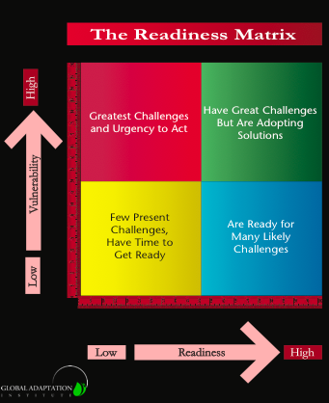
to receive and implement adaptation projects. Based on these two criteria, countries fall into one of four categories, such as highly vulnerable yet prepared, or low vulnerability and low preparedness.

The rest of this section describes how we calculated, combined and chose indicators to populate this Matrix. A more in-depth discussion of Vulnerability and Readiness indicators follows in the next two sections.

Vulnerability Axis:
This axis seeks to capture exposure to climate related hazards, sensitivity to their impacts and the ability to cope with those impacts. Vulnerability, as illustrated below, has 3 categories representing the core components of vulnerability (rows in the table), and 4 key sector indicators for each category (columns) based on the vulnerability literature and advice from potential users. In this initial version of the index a single indicator was selected for each of the sectors within each of the categories. Each category has equal weight, but the indicators for the specific sectors have different weights (for example in the first row food = 0.33, water = 0.33, health = 0.22, coastal protection = 0.11). Higher scores mean higher vulnerability. With negative weights, the weightings for some indicators become increasingly negative, meaning they increasing improve vulnerability.
Figure 1. Original Readiness matrix framework.

 | Food  (0.33) | Water  (0.33) | Health  (0.22) | Coast  (0.11)
Biophysical Exposure (0.33) | Crop yield  0.11 | Precip. decrease  0.11 | Affected pop.  0.07 | Coastal Area  0.03 | Slow Indicators
Socioeconomic Sensitivity (0.33) | % Rural pop  0.11 | Freshwater  0.11 | Doctor & nurse  -0.07* | Coastal pop  0.03 | Medium Indicators
Adaptive Capacity  (0.33) | Hunger  0.11 | Pop w/ water  -0.11* | Infant mort.  0.07 | Coast wealth  -0.03* | Fast Indicators
Table 1. Vulnerability Conceptual framework

- Indicators with negative values measure the opposite of vulnerability hence the sign reversal.
- Each indicator’s weight is determined by the weight assigned to its sector and vulnerability category.

The indicators (with weights) used are:
33% Biophysical Exposure: The level of exposure to adverse biophysical impacts for a given magnitude of climate change (slow adjusting).
33% Food: Predicted cereal crop yield decrease per country [Wheeler, based on Cline]
33% Water: Projected future percentage precipitation decrease [CRU, 9 models A2 scenario]
22% Health: Proportion of population affected by climatic events in recent decades [CRED]
11% Coast: Percent of national land area less than 5m above sea level [PLACE]

33% Socioeconomic Sensitivity: The importance of a climate-sensitive system or sector for a country (adjust at medium rate).
33% Food: Percentage of total population classified as rural [WB]
33% Water: Annual freshwater withdrawal [WB]
-22% Health: Number of Doctors & Nurses per 1,000 [WB]
11% Coast: Percent of population living less than 5m above sea level [PLACE]

33% Socioeconomic Adaptive Capacity: The availability of economic, social, and institutional resources [for specific sectors] to cope with and adapt to the impacts of climate change (fast adjusting).
33% Food: Depth of hunger measured as deficiency in Kcal/person/day [WB]
-33% Water: Percentage of population with access to water and sanitation [WB]
22% Health: Infant Mortality per 1000, 2009 [WB]
-11% Coast: Measure of financial resources that might be applied to coastal protection: measured in GDP corrected for purchasing power parity per km² of coast area [WB and PLACE]

Readiness Axis:
This axis captures the readiness of a country’s private and public sectors to absorb additional investment resources and apply them effectively to increase the resilience of its communities to the effects of climate change and other global trends. The axis has 3 categories: Economy, Social, and Governance. The corresponding weight for each indicator within the three categories is provided:

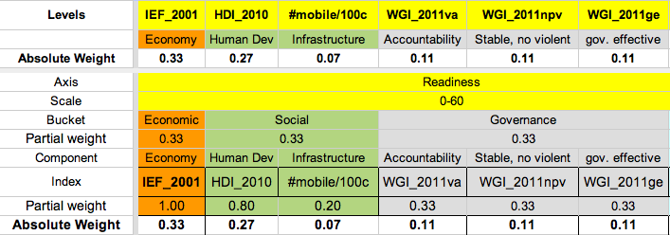
Table 2. Readiness Conceptual framework

The three categories receive equal weight (33%). Indicators within the categories (and their weights) are:
33% Economic: Ability to provide a hospitable financial, legal and regulatory investment environment.
100% Index of Economic Freedom 2011.
33% Social: The human and physical capital available to transform investments into effective projects and climate resilient enterprises.
80% Human Development Index 2010 [UNDP].
20% Infrastructure. Proxy: mobile phones per 100 people, in 2009. [ITU]
Allows rapid access to information and communication. It allows rapid situation awareness for decision making and supports other activities (like healthcare support, new business models or supporting government transparency)
33% Governance: Strong institutions will ensure that investments more effectively meet the needs of the population.
From the World Governance Indicators 2009 we chose 3 sub-components that do not overlap with the Index of Economic Freedom. They are equal weighted [Kaufmann]
33% Voice & Accountability.
33% Political Stability & No Violence.
33% Government Effectiveness.

Weighting Criteria

Whenever possible we try to obtain a complete set of the best, most general, independent, and comparable Indicators. Therefore, our preference is to weight all components equally. The exceptions in this version are:
- We have decided to give a stronger weight to the Readiness axis than to the Vulnerability axis (60 vs. 40, respectively). Therefore, to compute the total country scores, we rescale Readiness scores to a global maximum of 60 and Vulnerability to a global maximum of 40.
- The Awareness component is not yet ready, and therefore currently has 0 weight.
- The Human Development Index (HDI) measures social Readiness. We also include an infrastructure and communications component that reflects physical capital , which is not captured in HDI. HDI receives 80% of the social category weigh and the number of mobiles per 1,000 habitants receives 20%.
- For Vulnerability, we have 4 sectors: Food, Water, Health and Coast. Instead of using the same weights (25% each) we decided to give stronger weights to Food and Water (33% each). Health is weighted slightly less (22%), and Coast has the smallest weight (11%). This weighting scheme reflects an emphasis on sectors believed to be more important to our mission of improving lives and investing in sectors that can have the highest impact in reducing vulnerability. Further, improvement in the Food and Water sectors will also contribute to improvements in Health, so the overall effective weighting for Health is actually higher than 0.22.

Methodology

There are many ways in which the separate indicators can be combined to form a final index. A strong conceptual model of Vulnerability and Readiness can guide the methods used. Some prefer a multiplicative function implicit in the common (e.g. IPCC) representation of vulnerability as a function of exposure, sensitivity and capacity, but others argue that vulnerability is essentially a problem of minimum values and limits and thus some sort of threshold function is more appropriate. In all cases the indicators have to be scaled so that they fall within equivalent ranges and decisions have to be made about outliers. Preliminary examinations found that different methods of combining indicators lead to similar outcomes, especially in terms of the final ranking of countries. Work will continue within GaIn™ to explore these methodologies and to look more closely at the factors that lead to the final indices for particular countries.

At this stage, we use a common approach. The separate indicators are normalized, in some cases outliers scaled back to more moderate scores and the indicators are weighted and added. Mathematically:

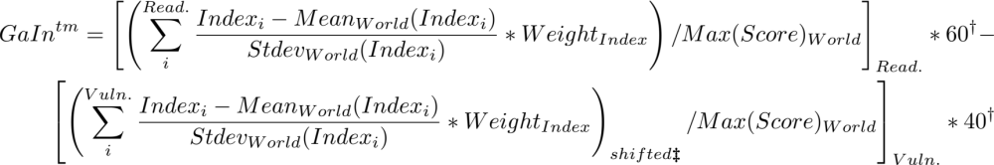

Footnotes:
† For the total Score, Readiness is scaled to 60, and Vulnerability to 40.
‡ Vulnerability score can be negative, we shift everything so it starts at zero.

Computation steps:

  - Each Indicator is converted into standardized scores (z-value) within available countries.
  - Standardized scores for each Indicator are weighted and aggregated (sum).
  - Since summed vulnerability scores can be negative, Vulnerability scores for all countries are equally shifted to make the most negative country score equal to zero.
  - Scores for each axis are rescaled (max 60 for Readiness, max 40 for Vulnerability).
  - The overall GaIn™ ordinal ranking is calculated as Readiness minus Vulnerability
  - We also produce the percentage change in Readiness score over the past 5 years. In this case the scores are not the latest value as above, but the change between the latest available and 5 years before, divided by the geometric mean of those two scores. Indicator weights remain the same. The weighted sum of these percentage changes is the total “change in Readiness” score.

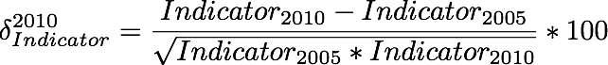

Other Notes regarding the methodology:

- Normalization: Score values are converted to standard scores (z-values). Z-values subtract score values to the average score for all the countries, and then divide by the standard deviation (stdev) of those scores. The resulting measure compares values relative to other countries in units of stdev. If all values are clustered, the unit is small (higher granularity). If values are dispersed, or a few deviate significantly from the mean, the granularity is coarse.

- Orthonormality/Correlations: The Readiness and Vulnerability Indices are not perfectly orthogonal (Independent) (especially through Adaptive Capacity), or even among categories. We also do not assume that the set of indices is complete in terms of perfect measurement of our indicators. Neither do we assume a perfect normalization process (same weight). We chose the smallest and simplest set of indices that provide the most information. Correlations among indicators and with other variables like GDPpc are present and expected. We seek to minimize this issue as we improve the model.

- Missing or outdated data: If a country has missing data, we remove it entirely from the model. In some cases we fill the most sensible value; for example landlocked countries and the sea-level rise effect, or adding a 0 value for victims from climate disasters in the CRED database.

- Historical data. If a country has no data for the year under study (2009 for this version) we choose the closest available. It is our intention to interpolate so that we can present a temporal representation for every component and the overall scores and rankings.

- Forecast data. Some of our indicators are expected outcomes from a variety of climate change models that rely on other historical data and varying assumptions.

Vulnerability Categories and Indicators

Our treatment of vulnerability follows that of many others in that it seeks to capture exposure to climate related hazards, sensitivity to their impacts and the ability to cope with those impacts. This concept is summarized in the IPCC Fourth Assessment Report: “Vulnerability is the degree to which a system is susceptible to, and unable to cope with, adverse effects of climate change, including climate variability and extremes. Vulnerability is a function of the character, magnitude, and rate of climate change and variation to which a system is exposed, its sensitivity, and its adaptive capacity.”

There are many interpretations of the concept of vulnerability, even among those who accept the basic construct. But our approach aligns with the advice that we have received from a number of advisors. For example, Dr. Caroline Sullivan noted during our Oct. 2010 meeting that exposure, sensitivity, and adaptive capacity capture different elements of vulnerability. With adaptation being the “procedural response to a real or perceived threat.”

Further, we generally use the framework of Hans-Martin Füssel, currently with the European Environment Agency, to identify our exposure and resiliency indicators (Füssel, 2010). Füssel explicitly uses the IPCC definition to categorize indicators for four climate-sensitive sectors -- water, food, health, and coasts. We have taken this as a starting point in developing GaIn™ for several reasons:

- Operating within the IPCC framework helps us communicate and compare with other efforts more easily and authoritatively
- The division of indicators into "biophysical exposure, "sensitivity," and “capacity” allows us to better communicate which indicators are actionable and those that are less so. For instance, capacity indicators = actionable indicators, i.e. indicators that countries can seek to change within a period of a few years. Biophysical and exposure indicators are less actionable and might take decades to improve, because they may require global agreements on mitigation measures, controlling population distribution, or altering the physical landscape. In GaIn™ these indicators are labeled as “slow”, “medium“ and “fast” indicators.
- This approach compliments previous GaIn™ discussions that enhancement of adaptive capacity targets social rather than biophysical vulnerabilities and that we must recognize that there are absolute barriers that may prevent some resilience.

A number of existing vulnerability models have been called into question due to underlying methodological problems, inconsistent data comparisons among existing methodologies, and results that challenge assumptions of vulnerability. Thus, at present, we believe our value added is not proving that our vulnerability model is the best for predicting the exact vulnerability levels of countries, but in signifying how countries can improve their resiliency to climate change.

Further, like Readiness, our Vulnerability score is correlated with GDP, indicating that we could just use GDP as an overall indicator. However, by organizing our indicators as we do we help countries and investors to target specific sectors vulnerable to climate change.

Biophysical Exposure

Indicator 1: Water - Future precipitation [CRU]
Explanation: Median % increase in precipitation from 9 climate models. Ian Noble computed for each country the median projection of 9 different GCM climate scenarios held by the UK-based Climate Research Unit. While improvements in modeling and uncertainty can change projections, this approach provides a general assessment of purely physical changes in future water supply. Ian Noble has suggested that “water runoff indicators” may be a better signal. However we have not yet found a suitable source of data.
Coverage: 187 countries
Credibility: Credible
Availability: Accessible
Effectiveness: Total future runoff, if data becomes available, may be a better indicator.
Longevity: Yes.
Scalability: Scalable to subnational within the model.
Source: http://www.cru.uea.ac.uk/

Indicator 2: Food - Crop yields [Wheeler, 2011]
Component Indicators: Agricultural Productivity Loss
Explanation: Wheeler bases predictions of future agricultural productivity changes on the results of Cline (2007). Cline’s data set uses midrange IPCC emissions forecasts, central tendencies in temperature across a number of Global Circulation Models, and combined estimates from technical and economic models of farmers’ responses to changing weather conditions. The resulting number is clearly a biophysical indicator because it does not take into account human exposure/dependence on crop production, just total production.
Coverage: 233 countries (187 used)
Credibility: Credible. A recent working paper from Wheeler, well respected in the field.
Effectiveness: Crops yields are a very difficult indicator to predict, either go with the best (probably the Cline model) or seek another indicator that is easier forecast
Availability: Accessible.
Longevity: Uncertain, modifications to such studies will likely frequently take place.
Scalability: Scalable to subnational within the model.
Source: http://www.cgdev.org/content/publications/detail/1424759

Indicator 3: Health - Climatic disaster
Component Indicators: Climatic disasters per capita (95)
Explanation: People affected by climatic events (floods, fires, droughts, and storms) in recent decades as measured by CRED (Centre for Research on the Epidemiology of Disasters) data through its searchable database. This represents a direct measure of the current threat of climate hazards to human populations and the health consequences that follow.
Coverage: 187, countries without disasters are not reported.
Credibility: Credible.
Effectiveness: Good. Will need to explain and justify “people affected.” There may be other sub indicators to use.
Availability: Accessible.
Longevity: Yes. Data reporting has improved in last few decades and is expected to continue to improve.
Scalability: Scalable to subnational.
Source: http://www.cred.be/

Indicator 4: Coastal Zones - Percentage of Land Below 5 meters [PLACE II]
Component Indicators: Percentage of Land Below 5 meters.
Explanation: Amount of coastline below 5 meters reflects likelihood of physical impacts on coasts as sea levels rise and storm surges move further inland.
Coverage: 228 countries.
Credibility: Credible. Columbia University. Often cited by other models. (Suggested by Füssel, 2010)
Effectiveness: Good. This indicator is often used by other models. One question remains. We use 5 meters but, is 1 meter, 3 meters, 10 meters a better indicator?
Availability: Yes
Longevity: This data will be available regardless of institutional longevity
Scalability: Scalable to subnational.
Source: http://sedac.ciesin.columbia.edu/place/

Socioeconomic Sensitivity

Indicator 5: Water - Annual freshwater withdrawal [WB]
Component indicators: Annual freshwater withdrawals, total (% of internal resources).
Explanation: Measured as % withdrawal of internal freshwater resources. Countries already straining water resources will be particularly affected by significant alterations in precipitation patterns (coupled with population growth).
Coverage: 187 countries.
Credibility: Credible. World Bank. (Suggested by Füssel, 2010)
Effectiveness: Good.
Availability: Accessible.
Longevity: Yes. World bank.
Scalability: Scalable to subnational.
Source: http://data.worldbank.org/indicator/ER.H2O.FWTL.ZS

Indicator 6: Food - Rural % of total population [WB]
Component Indicators: Rural population (% of total population)
Explanation: Rural populations are typically more dependent upon local agriculture for basic sustenance.
Coverage: 187 countries
Credibility: Credible. World Bank. (Suggested by Füssel, 2010)
Availability: Accessible.
Effectiveness: Good, though other indicators beyond rural could be considered.
Longevity: Yes.
Scalability: Scalable to subnational.
Source: http://data.worldbank.org/indicator/SP.RUR.TOTL.ZS

Indicator 7: Health - Doctor/Nurse numbers [WB]
Component indicators: Medical Support Index (2*Doc + Nurse)
Explanation: Medical providers per 1,000. People in a country with a low ratio will have greater exposure to disease and deaths from natural disasters. Data shows that countries have about twice as many nurses as doctors, so the 2x weighting gives approximately equal rating to both professions.
Coverage: 187
Credibility: Credible.
Availability: Accessible.
Effectiveness: Good.
Longevity: Yes.
Scalability: Scalable to subnational.
Source: http://data.worldbank.org/indicator/SH.MED.NUMW.P3

Indicator 8: Coastal zones - Population near sea level [PLACE]
Component indicators: Percentage of country population below 5 meters
Explanation: A larger number means citizens in coastal zones (<5m) will be exposed to higher economic costs, infrastructure damage, and morbidity.
Coverage: 228 countries.
Credibility: Credible. Columbia University. Often cited by other models. (Suggested by Füssel, 2010)
Availability: Accessible.
Effectiveness: Good. Distance from coast, natural coastal buffers, and current infrastructure might be alternatives for differentiating risk.
Longevity: Yes.
Scalability: Scalable to subnational.
Source: http://sedac.ciesin.columbia.edu/place/

Socioeconomic Adaptive Capacity

Indicator 9: Water - Access to Sanitation [WB]
Component indicator: Access to an improved water source
Explanation: A useful measure of how well-equipped a country is to address current and future water distribution and access challenges.
Coverage: 183
Credibility: Credible. World Bank. (Suggested by Füssel, 2010)
Effectiveness: Good. Other indicators such as “improved water source” or basic water access might more effectively cut to the point. Since this is in the adaptive capacity category, we may want to produce several target indicators.
Availability: Accessible.
Longevity: Yes.
Scalability: Scalable to subnational.
Source: http://data.worldbank.org/indicator/SH.STA.ACSN

Indicator 10: Food - Hunger [WB]
Component indicator: Depth of hunger (kilocalories per person per day)
Explanation: Basic indicator of whether a country's food systems and infrastructure are working effectively.
Coverage: 183
Credibility: Credible. World Bank.
Effectiveness: Medium. Broad indicator. Perhaps there are other, more direct indicators capturing whether the food infrastructure can quickly adapt or if food systems are equitable.
Availability: Accessible.
Longevity: Yes
Scalability: Scalable to subnational.
Source: http://data.worldbank.org/indicator/SN.ITK.DPTH

Indicator 11: Health - Infant mortality [WB]
Component indicator: Infant mortality per 1000
Explanation: Indicates the degree to which the health system is delivering basic services.
Coverage: 187 countries
Credibility: Credible.
Effectiveness: Good. A general indicator for health services. We may want to branch out to more climate sensitive indicators.
Availability: Accessible.
Longevity: Yes.
Scalability: Scalable to subnational.
Source: http://data.worldbank.org/indicator/SH.DYN.MORT

Indicator 12: Coastal Zones - Coastal zone wealth [Noble]
Component Indicator: $PPP/area_lecz (landlocked = 1.5 times the average score of non-land-locked countries).
Explanation: GDP corrected for purchasing power parity divided by Low-elevation Coastal zone (“area_lecz”). Serves as a proxy to indicate the resources available to invest in coastal protection.
Coverage: 187 countries
Credibility: Credible.
Availability: Accessible.
Effectiveness: Alternatives would likely be based on more complex and less transparent modeling (E.g. DIVA).
Longevity: Yes.
Scalability: Scalable to subnational.
Source: World Bank/Ian Noble

Energy/Other sectors

One other potential sector for GaIn™ to address is Energy. Most adaptation models focus on food, water, coastal protection, or health, so GaIn™ has concentrated on these. However, energy is certainly important in the context of climate change, resource constraints and socioeconomic progress. Fossil fuel-based (primarily electric utilities), nuclear, and hydroelectric energy sources may be highly sensitive to shifts in water levels/provisions. Further, power lines and energy transmission systems may be susceptible to disruption for increasing storm intensity.

Regarding possible Energy Indicators within our framework, we could use the following:
- Biophysical: “damage to energy infrastructure from natural disasters.”
- Socioeconomic: “percentage of energy dependent on water resources/ecosystem services.”
- Adaptive capacity: “redundancy of energy sources in a country” or “percentage of people with secure access to electricity.”

Further review and internal consultation about Energy are planned.

Readiness Categories and Indicators

The Readiness axis seeks to represent the ability of a country’s private and public sectors to absorb additional investment resources and apply them effectively to increase resiliency to climate change. This focus is similar in spirit to the World Bank’s Country Policy and Institutional Assessment (CPIA) measurements, which determine development assistance funding for low income countries based on performance in implementing policies that promote economic growth and poverty reduction.

We reviewed many different economic indices, such as the Word Bank’s Doing Business Indicators (DBI), the Heritage Foundation’s Index of Economic Freedom (IEF), and Transparency International’s Corruption Perception Index (CPI). All are excellent indicators. There is overlapping among these, as a sub-component of one index is based on a sub-component of another. We ultimately chose to use the IEF because it uses many DBI indicators and includes the CPI.

To minimize overlapping, we use a minimum of indices that cover most of the information concerning effective economic governance and human development. Still, these indicators are often correlated with each other, and with GDP (or GNI) per capita.

Currently, we provide both “Readiness” and “Improvement in Readiness” scores. Hence, while Country A and Country B may score equally for Readiness, Country A’s indicator improvement in the last 5 years may be considerably more. This information is important to investors who may want to invest in riskier but high return countries (low initial Readiness but significantly improving Readiness). As Daniel Kaufmann emphasized at the October 2010 meeting with the Institute, users and end clients are often primarily concerned with determining how they can improve upon indicators measured, Adding the dimension of improvement in Readiness can help users interested in a better measure.

Economic

Indicator 13: Index of Economic Freedom [Heritage Foundation]
Component Indicators: Business freedom, trade freedom, fiscal freedom, government spending, monetary freedom, investment freedom, financial freedom, property rights, freedom from corruption, labor freedom.
Explanation: This indicator uses information from the Doing Business Index and the Corruption Perception Index while covering several additional economic variables. This indicator reflects the ability of a country to move quickly and effectively to address climate challenges. Improving scores indicate that a country is better able to efficiently and quickly utilize investment capital.
Coverage: 183 countries
Access: Accessible.
Credibility: Credible Highly correlated (0.82) with the Doing Business Index. Produced by The Heritage Foundation and Wall Street Journal.
Effectiveness: Good. Comprehensive. Includes key indicators of concern to investors.
Longevity: In existence since 1995.
Scalability: National with some components scalable to subnational.
Source: http://www.heritage.org/index/

Social
Indicator 14: Human Development Index [UNDP]
Component Indicators: Health (Life expectancy at birth), Education (Mean years of schooling and Expected years of schooling), Living standards ( Gross national income per capita)
Explanation: Index reflects the health of the people within a nation and overall human capital. Improvement in this indicator reflects the increased readiness of the population to provide the necessary human capital to implement adaptation initiatives.
Coverage: 177 countries
Access: Accessible.
Credibility: Credible. Conducted by UNDP since 1990.
Effectiveness: Good.
Longevity: In operation since 1990.
Scalability: National with some components scalable to subnational.
Source: http://hdr.undp.org/en/statistics/hdi/

Indicator 15: Mobile cellular subscriptions (per 100 people) [ITU]
Component Indicators: Mobile cellular subscriptions (per 100 people)
Explanation: Mobile phones serve as a proxy for infrastructure and access to information and knowledge. They are relevant in many sectors and activities, such as personal communications, enabling new economic activities ( e.g. microfinance), healthcare management or crisis response, among others.
Coverage: 233 countries
Access: Accessible.
Credibility: Credible. ITU.
Effectiveness: Good. Not tested or used in other models. Makes sense to GaIn™ for now.
Longevity: Strong longevity, unless a new technology appears that replaces the usefulness of mobiles as an indicator. This data has been gathered since 1980.
Scalability: National but potentially scalable to subnational.
Source: http://data.worldbank.org/indicator/IT.CEL.SETS.P2

Governance
Indicator 16: World Governance Indicator - Voice & Accountability
Component Indicators: Comprised of many indicators. Part of the World Governance Indicator.
Explanation: This indicator reflects the ability of a country to respond to its people’s natural resource allocation needs. Improvement indicates that a country’s government is more responsive to the biophysical and capacity needs of its citizens as the climate changes.
Coverage: 199 countries
Access: Accessible.
Credibility: Credible.
Effectiveness: Good.
Longevity: Around since 1996. Should be published for foreseeable future unless underlying methodology changes.
Scalability: National but some components scalable to subnational.
Source: http://info.worldbank.org/governance/wgi/resources.htm

Indicator 17: World Governance Indicator - Political Stability & Absence of Violence
Component Indicators: Comprised of many indicators. Part of the World Governance Indicator.
Explanation: This indicator measures the public perceptions of the likelihood that the government will be destabilized or overthrown by unconstitutional or violent means, including domestic violence and terrorism. Improvement means a greater assurance to investors that their invested capital will grow without significant interruption and not be wiped out by political upheaval.
Coverage: 199 countries
Access: Accessible.
Credibility: Credible.
Effectiveness: Good.
Longevity: Around since 1996. Should be published for foreseeable future unless underlying methodology changes.
Scalability: National but some components scalable to subnational.
Source: http://info.worldbank.org/governance/wgi/resources.htm

Indicator 18: World Governance Indicator - Government Effectiveness
Component Indicators: comprised of many indicators. Part of the World Governance Indicator.
Explanation: Captures perceptions of the quality of public services, the quality of the civil service and the degree of its independence from political pressures, the quality of policy formulation and implementation, and the credibility of the government's commitment to such policies. Improvement in this indicator reflects a country’s ability to respond to the needs of its citizens.
Coverage: 199 countries
Access: Accessible.
Credibility: Credible.
Effectiveness: Good.
Longevity: Around since 1996. Should be published for foreseeable future unless underlying methodology changes.
Scalability: National but some components scalable to subnational.
Source: http://info.worldbank.org/governance/wgi/resources.htm

Adaptometer™
Recognizing that many of the impacts of climate change and solutions to building resilience exist at the local level, GaIn™ intends to develop an additional input, the “Adaptometer™”, to complement our metrics. This component would be subjective. The goal is to provide information on how aware are national and local governments and the private sector to the sensitivity of their jurisdictions and operations to climate impacts. If they are, how do they plan to adapt? This Adaptometer™ will capture a society’s awareness of the reality and immediacy of increasing climate hazards. Questions addressed could include:

- Does the society of the country understand its climate risks?
- How strong is the political will to address Adaptation needs?
- Are the decision makers and communities prepared to increase adaptive capacity?
- Is there an open, inclusive, results oriented national and sub-national dialogue on Adaptation?
- Do budgets reflect a commitment to Adaptation?
- Other questions will be developed dependent on the reality, level of progress and capacity of institutions on the ground to conduct such polls.

This component could not be included at this stage, due to a lack of data and a concrete definition of this concept. However, we argue that it could provide valuable information consistent with the framework and purpose of our model. Methodologically, we could include this component as an additional category in Readiness, or as an independent Axis (possibly combined with Adaptive Capacity).

We believe developing this concept can strengthen current metrics as well as contribute to the advocacy part of the Institute’s goals. Hopefully it would create a snowball effect for implementation of public policies that produce long term, fiscally sound solutions to vulnerable groups in society.

The Adaptometer™ would use information from the field that describes the level of knowledge, the policies in place, the allocation of budgets, and the overall commitment of society to adapting to climate change and other global trends. Concretely, polling/questionnaires would be conducted on public officials at national and local levels, plus representatives of the private sector, civil society, unions, universities, and think tanks.

Results

In the following pages we present different types of visuals derived from the information we obtained. They depict the ability of this model to present concise results and rankings, as well as more focused reports, trends, and correlations. If you have only a hard copy, you are invited to use the “live” web version for greater clarity.

Ranking table

Ranking a sub-section of countries by total scores derived from Indicator scores (shown). Click here for high resolution version http://bsan.eu/table_ranking
(see next page)
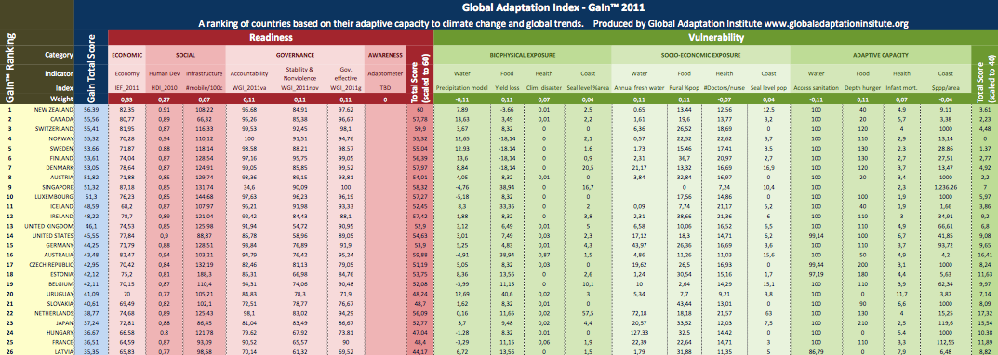
Table 3. Country Rankings

Readiness Bar plot

Countries ordered by Readiness score. Country labels on all following graphs are an automatic sub-section of all countries available. Click here for live version bsan.eu/Gain_v05

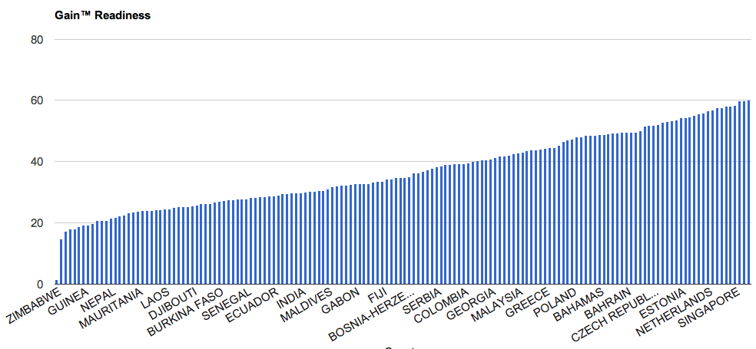
Figure 2. Readiness scores. Not all country labels are shown.

Vulnerability Bar Plot
Countries ordered by Vulnerability score. Click here for live version bsan.eu/Gain_v05

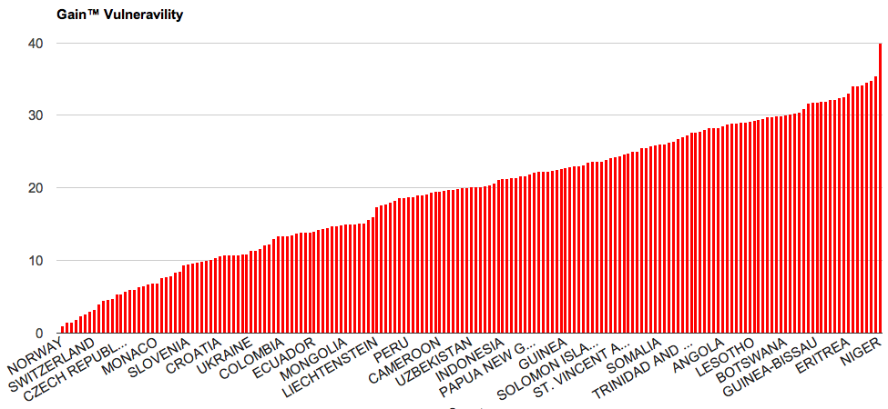
Figure 3. Vulnerability scores. Not all country labels are shown.

Stacked bars
Countries ordered on the horizontal axis by net (Readiness minus Vulnerability) total Score. Blue positive and red negative stacked bars are, respectively, Readiness and Vulnerability. Click here for live version bsan.eu/Gain_v05

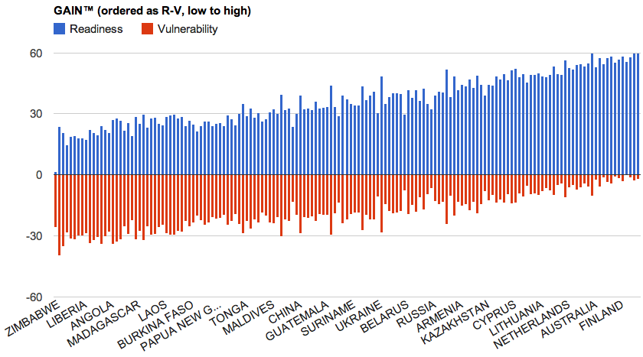
Figure 4. Stacked bars for Readiness (blue) and Vulnerability (Red). Countries are ordered from left to right as Readiness-Vulnerability. Not all country scores are shown.

GaIn™ Map

Ranking map. Blue shade countries have higher scores in Readiness than Vulnerability. Red shaded countries have higher scores in Vulnerability than Readiness. For interactive version, click here http://bsan.eu/gain05_map

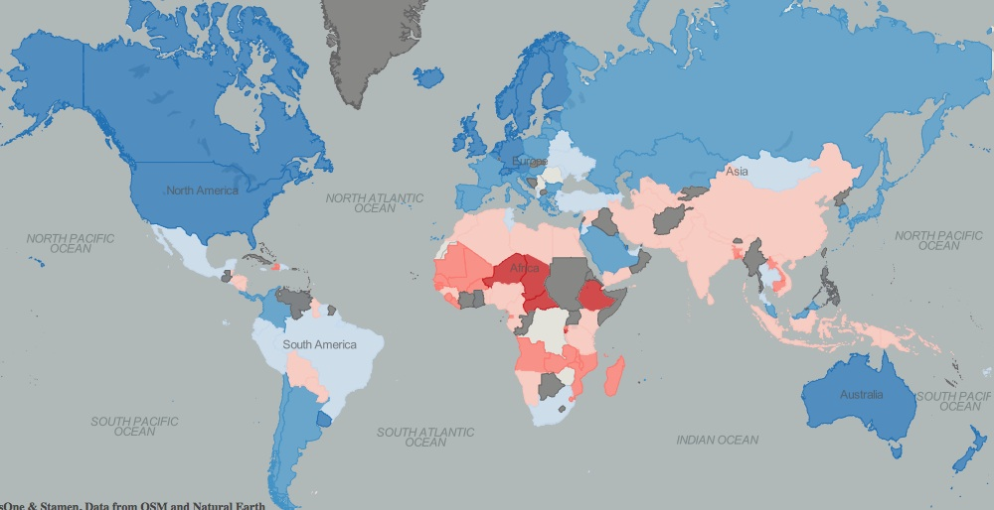
Figure 5. Map overlay with scores. Blue shades correspond to higher (darker) Readiness than Vulnerability (the darker the shade, the bigger the difference). Red shades correspond to higher Vulnerability than Readiness.

Matrix

In the interactive version axes can be switched among available options, as well as size of the data points and colors. Data points can be clicked to retain name labels, or selected through the country name list.
Click here for live version bsan.eu/Gain_v05 (then click on “Matrix” tab)
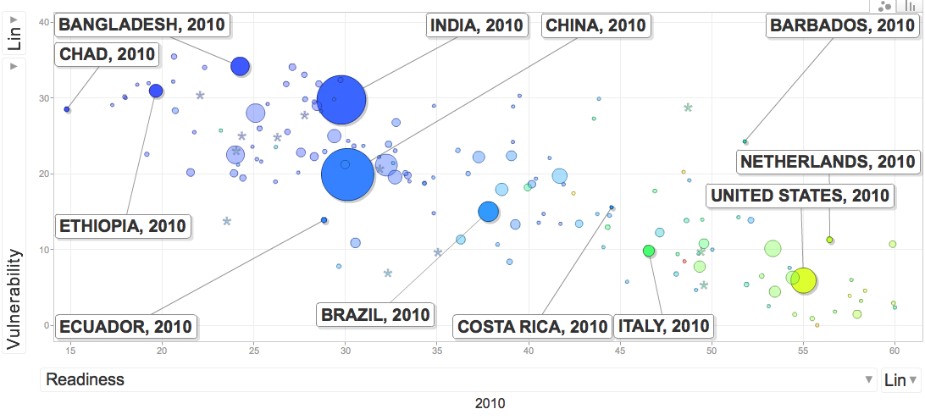
Figure 6. Readiness matrix. Abscissa is Readiness scores. Ordinates are Vulnerability. Size of the data points is proportional to the population. Color (blue, green, yellow) corresponds to GNIpc (low to high). Selected countries are labeled.

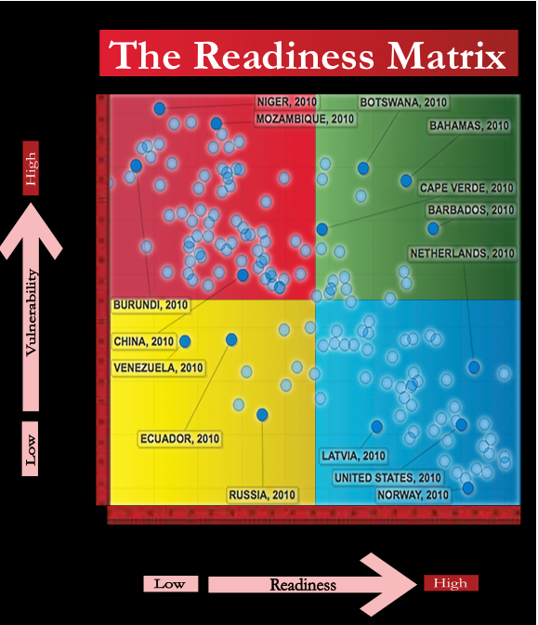
Figure 7. Overlay into the Matrix Concept.

Change in readiness

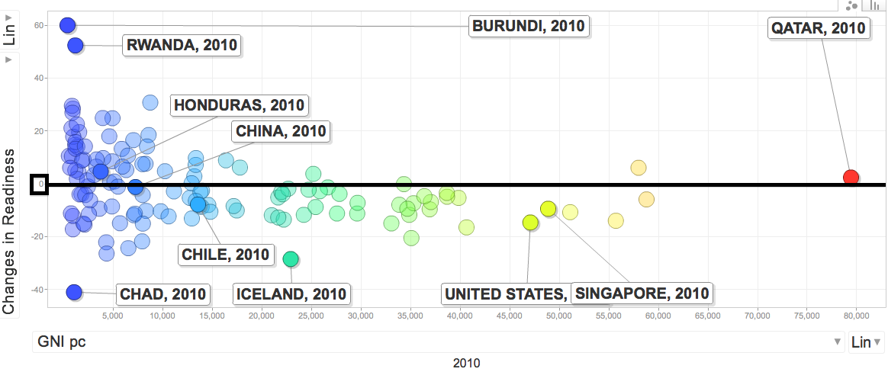
Figure 8. Change in Readiness (y-axis, standardized score of the % change) versus GNIpc (x-axis, and also color coded). Black horizontal line corresponds to no change.

An additional dimension we provide is the deltas (% change) over the last 5 years for each of the indicators used in Readiness. We aggregate the z-values of these deltas using the same weights as for the levels. We use z-values to take into account the different stddev in each case.

GDP correlations

GNIpc correlates both with Readiness (more strongly) and with Vulnerability. This correlation is common for many indices in the current literature, especially for Readiness. Some Indices do, indeed, use GDP (or GNI) as one of their explicit components. In Vulnerability, we have tried to minimize this dependence, avoiding where possible, Indices directly related to or using GDP. Further examination is necessary to determine how this correlation impacts the effectiveness of our indicators. While we believe that GNIpc strongly correlates, we still believe it is important to highlight specific indicators on which countries can make an impact or “move the needle.”

The following graphs show the apparent correlation of the “order of magnitude of GDPpc” (log GDPpc) with Readiness, Vulnerability, Total Score, and change in Readiness (in all country circle size reflects population). All graphs are available here bsan.eu/Gain_v05 (“Matrix” tab), select the appropriate options for the axes.

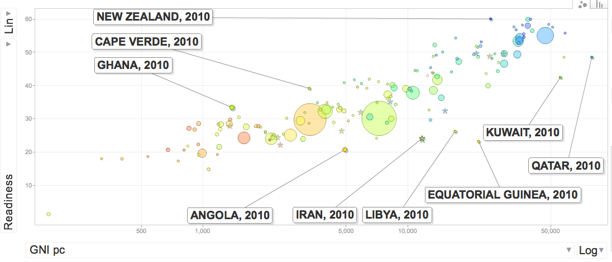
Figure 9. Log(GNIpc) vs Readiness. Color is Vulnerability. Size is proportional to population. Selected countries labeled.

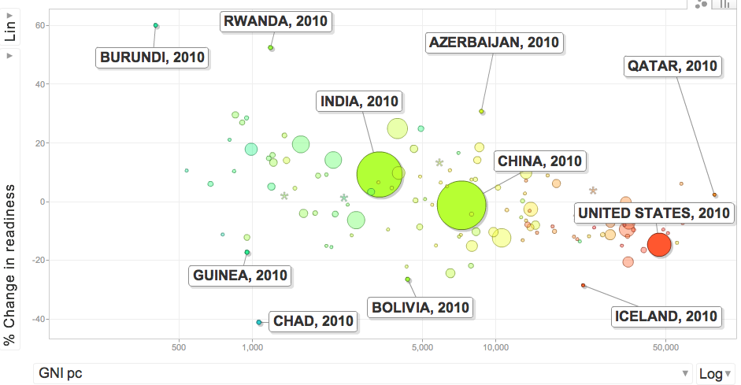
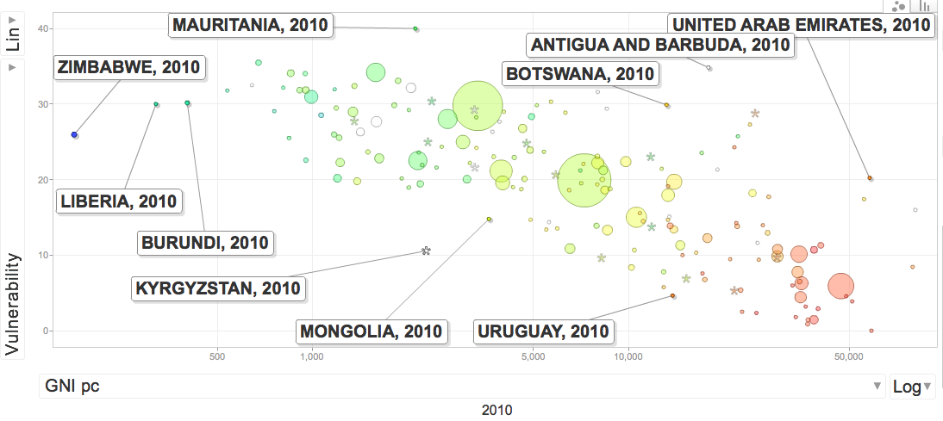
Figure 10. Log(GNIpc) vs Vulnerability. Color is Readiness. Size is proportional to population

Figure 11. Log(GNIpc) vs Change in Readiness. Color is Readiness. Size is proportional to population.

IEF vs. DBI indicators for Economic Readiness

In our current model we chose the Index of Economic Freedom as the Economic Indicator for Readiness. We believe it is the best candidate according to our criteria (mainly availability, coverage and access). Also, it includes data from other indices we consider important, such as the Corruption Perceptions Index.

Several reviewers have pointed out the possibility of using DBI (Doing Business Indicators) instead of IEF. The two Indices are highly correlated (r=0.8). We are open to continuing these conversations on selection. To support the debate, we include here a preliminary comparison of both Indices.

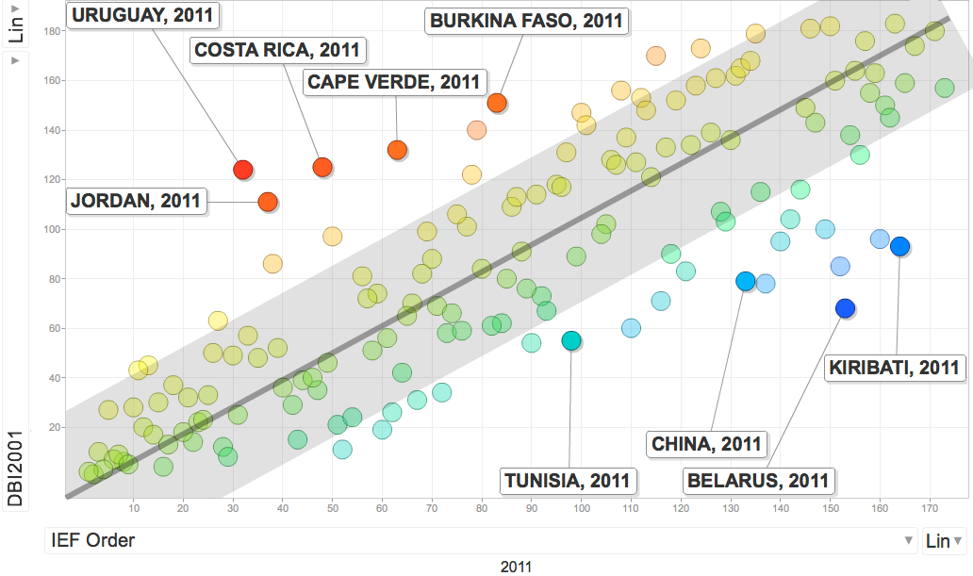
Figure 12. Comparison of DBI ranking and IEF. The Black line depicts minimal change among Indexes. The grey area corresponds to one unit of standard deviation of the difference.

In the above plot the horizontal axis illustrates the ordinal ranking IEF score for each country. The vertical axis shows the DBI rank. The black line approximates the prefect trend, where both Indicators would give the minimal difference in rankings. The grey area corresponds to one unit of standard deviation on each side. The difference in ranking is color coded for each data point. No differences correspond to green-yellow (closest to the black line) while red tones indicate higher DBI than IEF. Blue tones correspond to higher IEF than DBI. The IEF has 173 data points, while DBI has 163; in total 150 countries are common for this comparison.

References
(Selected titles, a more comprehensive list of material used to prepare this work can be found here.)

Bandura, Romina. 2008. A Survey of Composite Indices Measuring Country Performance: 2008 Update. UNDP. Available at: http://www.undp.org/developmentstudies/docs/indices_2008_bandura.pdf

Barr, R.; Fankhauser, S. and Hamilton, K.). 2010. Adaptation Investments: a resource allocation framework. Mitigation and Adaptation Strategies Global Change. Volume 15, Number 8, 843-858. Available at: http://www.springerlink.com/content/f07067w33863x781/

Brooks, Nick; Adger, Neil; Kelly, Mick. 2005. The determinants of vulnerability and adaptive capacity at the national level and the implications for adaptation. Global Environmental Change. 15. 151-163. Available at: www.uea.ac.uk/env/people/adgerwn/Brooksetal2005GEC.pdf

Capacity Strengthening in climate change vulnerability and adaptation strategy assessment: exercise 2 Vulnerability Indicators (ENDA). Available at: c3d-unitar.org/c3d/userfiles/Guide_for_trainers.pdf

Clark, W. C., Ed. (2002). The state of the nation's ecosystems: Measuring the lands, waters, and living resources of the United States. Cambridge, UK, Cambridge Univ. Press.

Climate Adaptation Knowledge Exchange. EcoAdapt. Available at: http://www.cakex.org/virtual-library/about

Climate Change adaptation indicators for the natural environment (Natural England Commissioned Report NECRO38. 2010). Available at: http://naturalengland.etraderstores.com/NaturalEnglandShop/NECR038

Climate change vulnerability and adaptation indicators. 2008. Harley, Mike; Horrocks, Lisa; and Hodgson, Nikki. Available at: http://air-climate.eionet.europa.eu/reports/ETCACC_TP_2008_9_CCvuln_adapt_indicators

Climate Vulnerability Monitor 2010. 2010. DARA – Climate Vulnerability Forum. Available at: http://daraint.org/climate-vulnerability-monitor/climate-vulnerability-monitor-2010/download-the-report/

Climate Research Unit. http://www.cru.uea.ac.uk/

Country Policy and Institutional Assessments (CPIA), 2009 Assessment Questionnaire. 2009. World Bank.

Cutter, Susan; Emrich, Christopher; Webb, Jennifer; and Daniel Morath. 2009. Social Vulnerability to Climate Variability Hazards: A Review of the Literature. Oxfam America. Available at: http://adapt.oxfamamerica.org/resources/Literature_Review.pdf

Davis, K.; Kingsbury, B; and Merry, S. 2010. Indicators as technology of global governance. IILI Working Paper. Global Administration Law Series. Available at: http://www.iilj.org/publications/2010-2.Davis-Kingsbury-Merry.asp

Debels, P.; C. Szlafsztein; P. Aldunce; C. Neri; Y. Carvajal; M. Quintero-Angel; A. Celis: A. Bezanilla; D. Martinez. 2009. IUPA: a tool for the evaluation of the general usefulness of practices for adaptation to climate change and variability. Natural Hazards 0:211-233.

Doing Business Index. 2010. World Bank. Available at: http://www.doingbusiness.org/rankings

EM - DAT. The International Disaster Database. Center for Research on the Epidemiology of Disasters - CRED. http://www.emdat.be/

Economic Conditions Snapshot, December 2010: McKinsey Global Survey results. 2010. McKinsey and Company. Available at: http://www.mckinseyquarterly.com/Economic_Conditions_Snapshot_December_2010_McKinsey_Global_Survey_results_2720

Economic Freedom of the World (EFW) Index. 2010. Fraser Institute. Available at: http://www.freetheworld.com/release.html

EIU Business Environment Rankings. 2010. Economist Intelligence Unit. Available at: http://www.eiu.com/public/

Environmental Sustainability Index. Benchmarking National Environmental Stewardship. 2005. Socioeconomic Data and Applications Center. Earth Institute, Columbia University and Yale Center for Environmental Law and Policy. Available at: http://sedac.ciesin.columbia.edu/es/esi/downloads.html

Environmental Performance Index. 2010. Center for International Earth Science Information Network, Columbia Univeristy and Yale Center for Environmental Law & Policy, Yale University. Available at: http://epi.yale.edu/

Environmental Vulnerability Index. 2005. South Pacific Applied Geoscience Commission (SOPAC) and United Nations Environment Programme. Available at: http://www.vulnerabilityindex.net/EVI_Background.htm

Failed States Index. 2010. Foreign Policy and Fund for Peace. Available at: http://www.fundforpeace.org/web/index.php?option=com_content&task=view&id=452&Itemid=900

Füssel, Hans-Martin. 2010. How inequitable is the global distribution of responsibility, capability, and vulnerability to climate change: A comprehensive indicator-based assessment. Global Environmental Change 20(4):597-611, 2010

Füssel, H. (2009) Review and Quantitative Analysis of Indices of Climate Change Exposure, Adaptive Capacity, Sensitivity, and Impacts. Background Note to World Bank Development Report 2010. Available at: http://wdronline.worldbank.org/worldbank/a/nonwdrdetail/145

Global Climate Risk Index. 2011. Germanwatch and Climate Action Europe. Available at: http://www.germanwatch.org/klima/cri.htm

Global Competitiveness Index. 2010. World Economic Forum. Available at: http://www.weforum.org/issues/global-competitiveness

Hedger, M.M., Horrocks, L., Mitchell, T., Leavy, J., and Greeley, M. (2010) ‘Evaluation of adaptation to climate change from a development perspective’, IN: Van Den Berg, R. and Feinstein, O.N. (Eds), ‘Evaluating Climate Change and Development’, Transaction Publishers for World Bank Series on Development.

Hinkel, J. (2011) “Indicators of vulnerability and adaptive capacity: Towards a clarification of the science–policy interface”, Global Environmental Change, Volume 21, Issue 1, Pages 198-208. Available at: www.loceanipsl.upmc.fr/~ESCAPE/Hinkel_2011.pdf

Horrocks, Lisa (AEA Group); McKenzie et al. (IDS). 2008. Institute of Development Studies. Available at: http://www.ids.ac.uk/go/idsproject/evaluating-adaptation-to-climate-change-from-a-development-perspective

How we can bend the curve: Global Footprint Network Annual Report. 209. Global Footprint Network. Available at: http://www.footprintnetwork.org/en/index.php/GFN/

Human Development Index. 2010. UNDP. http://hdr.undp.org/en/statistics/hdi/

Human Poverty Index. 2010. UNDP. Available at: http://hdr.undp.org/en/statistics/indices/hpi/

Index of Economic Freedom. 2010. The Heritage Foundation. Available at: http://www.heritage.org/index/

Kaufmann, Daniel; Kraay, Aart; Mastruzzi, Massimo. World Governance Indicators. 2009. Brookings Institution; World Bank Development Economics Research Group; and World Bank Institute. Available at: http://info.worldbank.org/governance/wgi/index.asp

Klein, R. 2009. Identifying Countries that are particularly vulnerable to the adverse effects of climate change: an academic of a political challenge (CCLR 3/2009 284-291.

Measuring adaptation to climate change: a proposed approach. DEFRA. 2010. Available at: http://archive.defra.gov.uk/environment/climate/.../100219-measuring-adapt.pdf

Mitchell, Tom; van Aalst, Maarten; and Villanueva, Paula Silva. 2010. Assessing Progress on Integrating Disaster Risk Reduction and Climate Change Adaptation in Development Processes. Institute of Development Studies. Available at: community.eldis.org/.59e0d267/Convergence.pdf

Moss, Richard; Malone, Elizabeth; and Brenkert, Antoinette. 2001. Vulnerability to Climate Change: A Quantitative Approach. Pacific Northwest Laboratory for the United States Department of Energy. Available at: http://www.globalchange.umd.edu/publications/118/

Myers, Mark et al. 2007. "USGS Goals for the Coming Decade.” Science, 12 October: Vol. 318. no. 5848, pp. 200-201. 2007

Vulnerability Indices for Planning Climate Change Adaptation. 2010. National Adaptation Program of Action (NAPA). Global Environment Facility. Available at: http://www.napa-pana.org/

National Aggregates of Geospatial Data Collection. Population, Landscape and Climate Estimates (PLACE). 2007. SEDAC. http://sedac.ciesin.columbia.edu/place/

Stewart, Richard; Kingsbury, Benedict; and Rudyk, Bryce. 2009. Climate Finance: Regulatory and Funding Strategies for Climate Change and Global Development. New York University Abu Dhabi Institute. New York University Press. New York and London. Available at: http://www.iilj.org/climatefinance/documents/Stewartetal-ClimateFinance.pdf

Sullivan, Caroline et al. 2003. The Water Poverty Index: Development and application at the community scale. Natural Resources Forum. 27. 189-199. Available at: ftp://ftp.fao.org/agl/emailconf/wfe2005/narf_054.pdf

Szlafsztein, Claudio; Aldunce, Paulina; and Neri, Carolina. 2008. Available at: captura.uchile.cl/jspui/bitstream/.../Evaluacion%20practicas%20utiles.pdf

Water Scarcity Index. 2008. UNEP. Available at: http://www.unep.org/dewa/vitalwater/article77.html

weADAPT 3.0. Collaborating on Climate Adaptation. Available at: http://weadapt.org/

Wheeler, David. 2011. Quantifying Vulnerability to Climate Change: Implications for Adaptation Assistance – Working Paper 240. Center for Global Development. Available at: http://www.cgdev.org/content/publications/detail/1424759

World Bank Indicators. 2010. Available at: http://data.worldbank.org/indicator

World Press Freedom Rating. 2010. Reporters Without Borders. Available at: http://en.rsf.org/press-freedom-index-2010,1034.html

World Resources Report 2010 Framing Paper: Decision Making in a Changing Climate. World Resources Institute. Available at: www.worldresourcesreport.org/files/wrr/framing_paper.pdf

World Telecommunication/ICT Indicators Database. 2010. International Telecommunications Union. Available at: http://itu.int/en

Vörösmarty, C.J. et al. 2010. Global threats to human water security and river biodiversity. Nature 467, 555–561, 19 Aug.

Submission form for additional sources available here: http://bsan.eu/Gain_biblio_form

Appendix 1: Glossary of Terms

Adaptometer™ | an indicator that captures information from the field that describes the level of knowledge, the policies in place, the allocation of budgets, and the overall commitment of society to adapting to climate change and other global trends. The Adaptometer™ will not only capture the “awareness” of the public and government on adaptation but what actions are being formulated and implemented.
Awareness | a concept that captures the reality at the local level, a society’s understanding of climate risks, and the prospects of change in the right direction for increasing adaptation capacity.
Biophysical exposure | the level of adverse biophysical impacts due to climate change and other global forces.
Fast indicator | an indicator that can change quickly, primarily due to human actions. Most Readiness and adaptive capacity indicators are fast indicators.
GaIn™ | Global Adaptation Institute and also used to identify the Global Adaptation Index™. A non-profit environmental organization guided by a vision of building resilience against climate change and other global forces as a key component to sustainable development. The mission of GaIn™ is to enhance the world’s understanding of the urgency for adaptation to climate change and other global forces and for the support needed through private and public investments for developing countries. Also the ranking model here presented.
Medium indicators | an indicator, which can change over time due to human actions. However, change may take place slowly, over decades rather than years.
Readiness | ability of a country’s private and public sectors to absorb additional investment resources and apply them effectively to increasing the resilience of its communities to the effects of climate change.
Readiness Matrix | a measurement of the comparative resilience of countries, plotting a country’s vulnerability to climate change with its readiness to confront climate challenges.
Slow indicator | an indicator, usually physical, that moves very slowly or may not change in a lifetime. Human action has little impact on changes in these variables.
Socioeconomic sensitivity | the importance of a climate-sensitive sector to a country. In other words, how exposed or sensitive a country is to impacts on water, food, coastal zones, and human health.
Socioeconomic adaptive capacity | the availability of economic, social, and institutional resources to cope with and adapt to the impacts of climate change in specific sectors. Though related, this differs from Readiness indicators in that it measures specific actions taken to increase resilience in specific sectors, whereas Readiness measures a country’s ability to easily facilitate these increases in resilience.
Vulnerability | a country’s socioeconomic exposure to biophysical impacts minus adaptive capacity.
Weight | the relative value or importance an indicator is assigned in determining a country’s overall Readiness and Vulnerability score.

Appendix 2: Scientists Meeting Attendees

List of participants in the Scientists Meeting on October 27, 2010 at the Bolger Center, Maryland, USA, where many of the GaIn™ concepts originated, including conceptualization of the Readiness Matrix. The Global Adaptation Institute would like to thank all of these international experts, while taking full responsibility of the production of the working model of GaIn™. There should be no explicit or implicit understanding that these experts endorse the current product.

- Nicholas Brooks, Visiting Research Associate at the School of Geography and the Environment at the University of Oxford
- William Clark, Harvey Brooks Professor of International Science, Public Policy and Human Development, at Harvard University
- Robert A. Edwards, Managing Director for NGP Energy Capital Management, LLC
- Lisa Horrocks, Principal Consultant, Climate Change Adaptation, AEA (England)
- Daniel Kaufmann, Senior Fellow, Global Economy and Development Program at the Brookings Institution
- Mark Klugmann, Communications and Strategy Consultant
- Heather McGray, Senior Associate at the World Resources Institute
- Marc Miles, Global Strategy Consultant
- Richard Moss, Senior Staff Scientist, Joint Global Change Research Institute, Maryland University
- Mark Myers, State of Alaska Natural Gas Pipeline Coordinator and Vice-Chancellor for Research at the University of Alaska Fairbanks.
- Ian Noble, Chief Scientist Global Adaptation Institute (formerly Lead Climate Change Specialist at the World Bank)
- Dr. Anand Patwardhan, Professor at the Indian Institute of Technology (participated connected using Skype).
- Richard Stewart, John Edward Sexton Professor of Law at the New York University.
- Caroline Sullivan, Associate Professor, School of Environmental Science and Management, Lismore, Australia.
- Claudio Szlafsztein, Professor , Environmental Science Center, Federal University of Pará, Brazil
- Mike Toman, Lead Economist on Climate Change at the World Bank

Füssel, Hans-Martin. 2010. How inequitable is the global distribution of responsibility, capability, and vulnerability to climate change: A comprehensive indicator-based assessment. Global Environmental Change 20(4):597-611, 2010
Throughout this document we use hyperlinks that, when clicked, direct to the appropriate section of the Model that is hosted online. If this is a printout, you can always access it on this address: http://bsan.eu/Gain_v05 (within the spreadsheet, refer to the appropriate Sheet Tab in the lower section of the page).
Füssel, Hans-Martin. 2010. How inequitable is the global distribution of responsibility, capability, and vulnerability to climate change: A comprehensive indicator-based assessment. Global Environmental Change 20(4):597-611, 2010
Füssel, Hans-Martin. 2009. Review and Quantitative Analysis of Indices of Climate Change Exposure, Adaptive Capacity, Sensitivity, and Impacts. Background note to the World Development Report 2010. World Bank, Washington, D.C. http://wdronline.worldbank.org/worldbank/a/nonwdrdetail/145
Former Lead Climate Change Specialist at the World Bank and currently Chief Scientist for the Global Adaptation Institute
We use this indicator instead of 3 suggested by Füssel. This gets to the core concept and is more readily available than Füssel’s citations. We do the same for several other indicators suggested by Füssel for which data is not easily attainable.
Scalability indicates the feasibility of applying the index at scales finer than national. Here we use national, sub-national, landscape-community and fully scalable.

